|  |  |
| --- | --- |
| **NAME:** | Bodhisatya Ghosh |
| **UID:** | 2021700026 |
| **BRANCH:** | T.Y. CSE Data Science |
| **BATCH:** | B |
| **SUBJECT:** | FOSIP |
| **EXP. NO.:** | 6 |

**AIM: -** To study image enhancement using point processing.

# OBJECTIVES:

1. Image Enhancement using recent published technique based on any one of the following operations.
   1. Enhancement using Point Operation
   2. Enhancement using Histogram Processing

**INTRODUCTION :**

Image enhancement using point processing is a fundamental technique in digital image processing that aims to improve the visual quality of images by directly manipulating individual pixel values. Point processing operations are applied independently to each pixel in the image, without considering the spatial relationships between pixels. The goal is to enhance specific visual features, such as contrast, brightness, or color, leading to a more visually appealing or analytically useful representation. In this method, a mathematical function is applied to the intensity values of each pixel, mapping them to a new range. Common point processing operations include contrast stretching, histogram equalization, and intensity scaling. Contrast stretching, for instance, involves expanding the range of pixel values to cover the full dynamic range, resulting in a more vibrant and perceptually enhanced image. Point processing techniques are versatile and widely used in various applications, including medical imaging, satellite imagery, and photography. They are computationally efficient and straightforward, making them suitable for real-time applications. However, the effectiveness of point processing may vary depending on the characteristics of the input images and the specific enhancement goals. Understanding the principles of image enhancement using point processing is crucial for professionals in fields like computer vision, remote sensing, and medical diagnostics, as it forms the foundation for more advanced image processing techniques. The simplicity and effectiveness of point processing make it a valuable tool in the broader landscape of image enhancement and analysis.

# HITOGRAM PROCESSING ALGORITM BLOCK-DIAGRAM

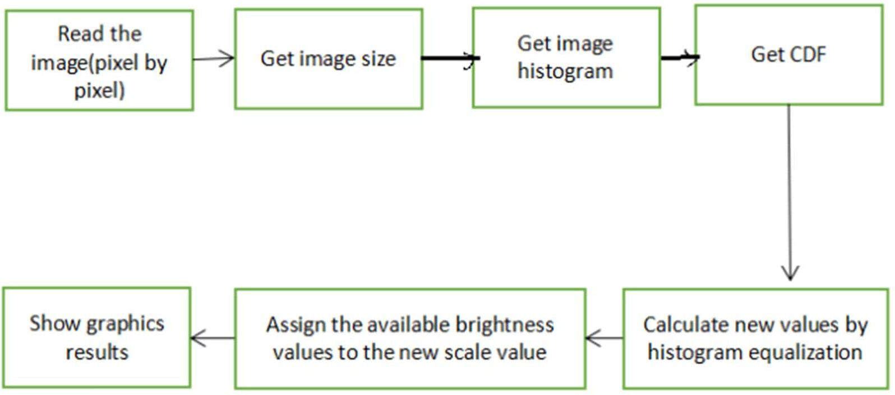

**EXPERIMENTATION:**

**CODE:**

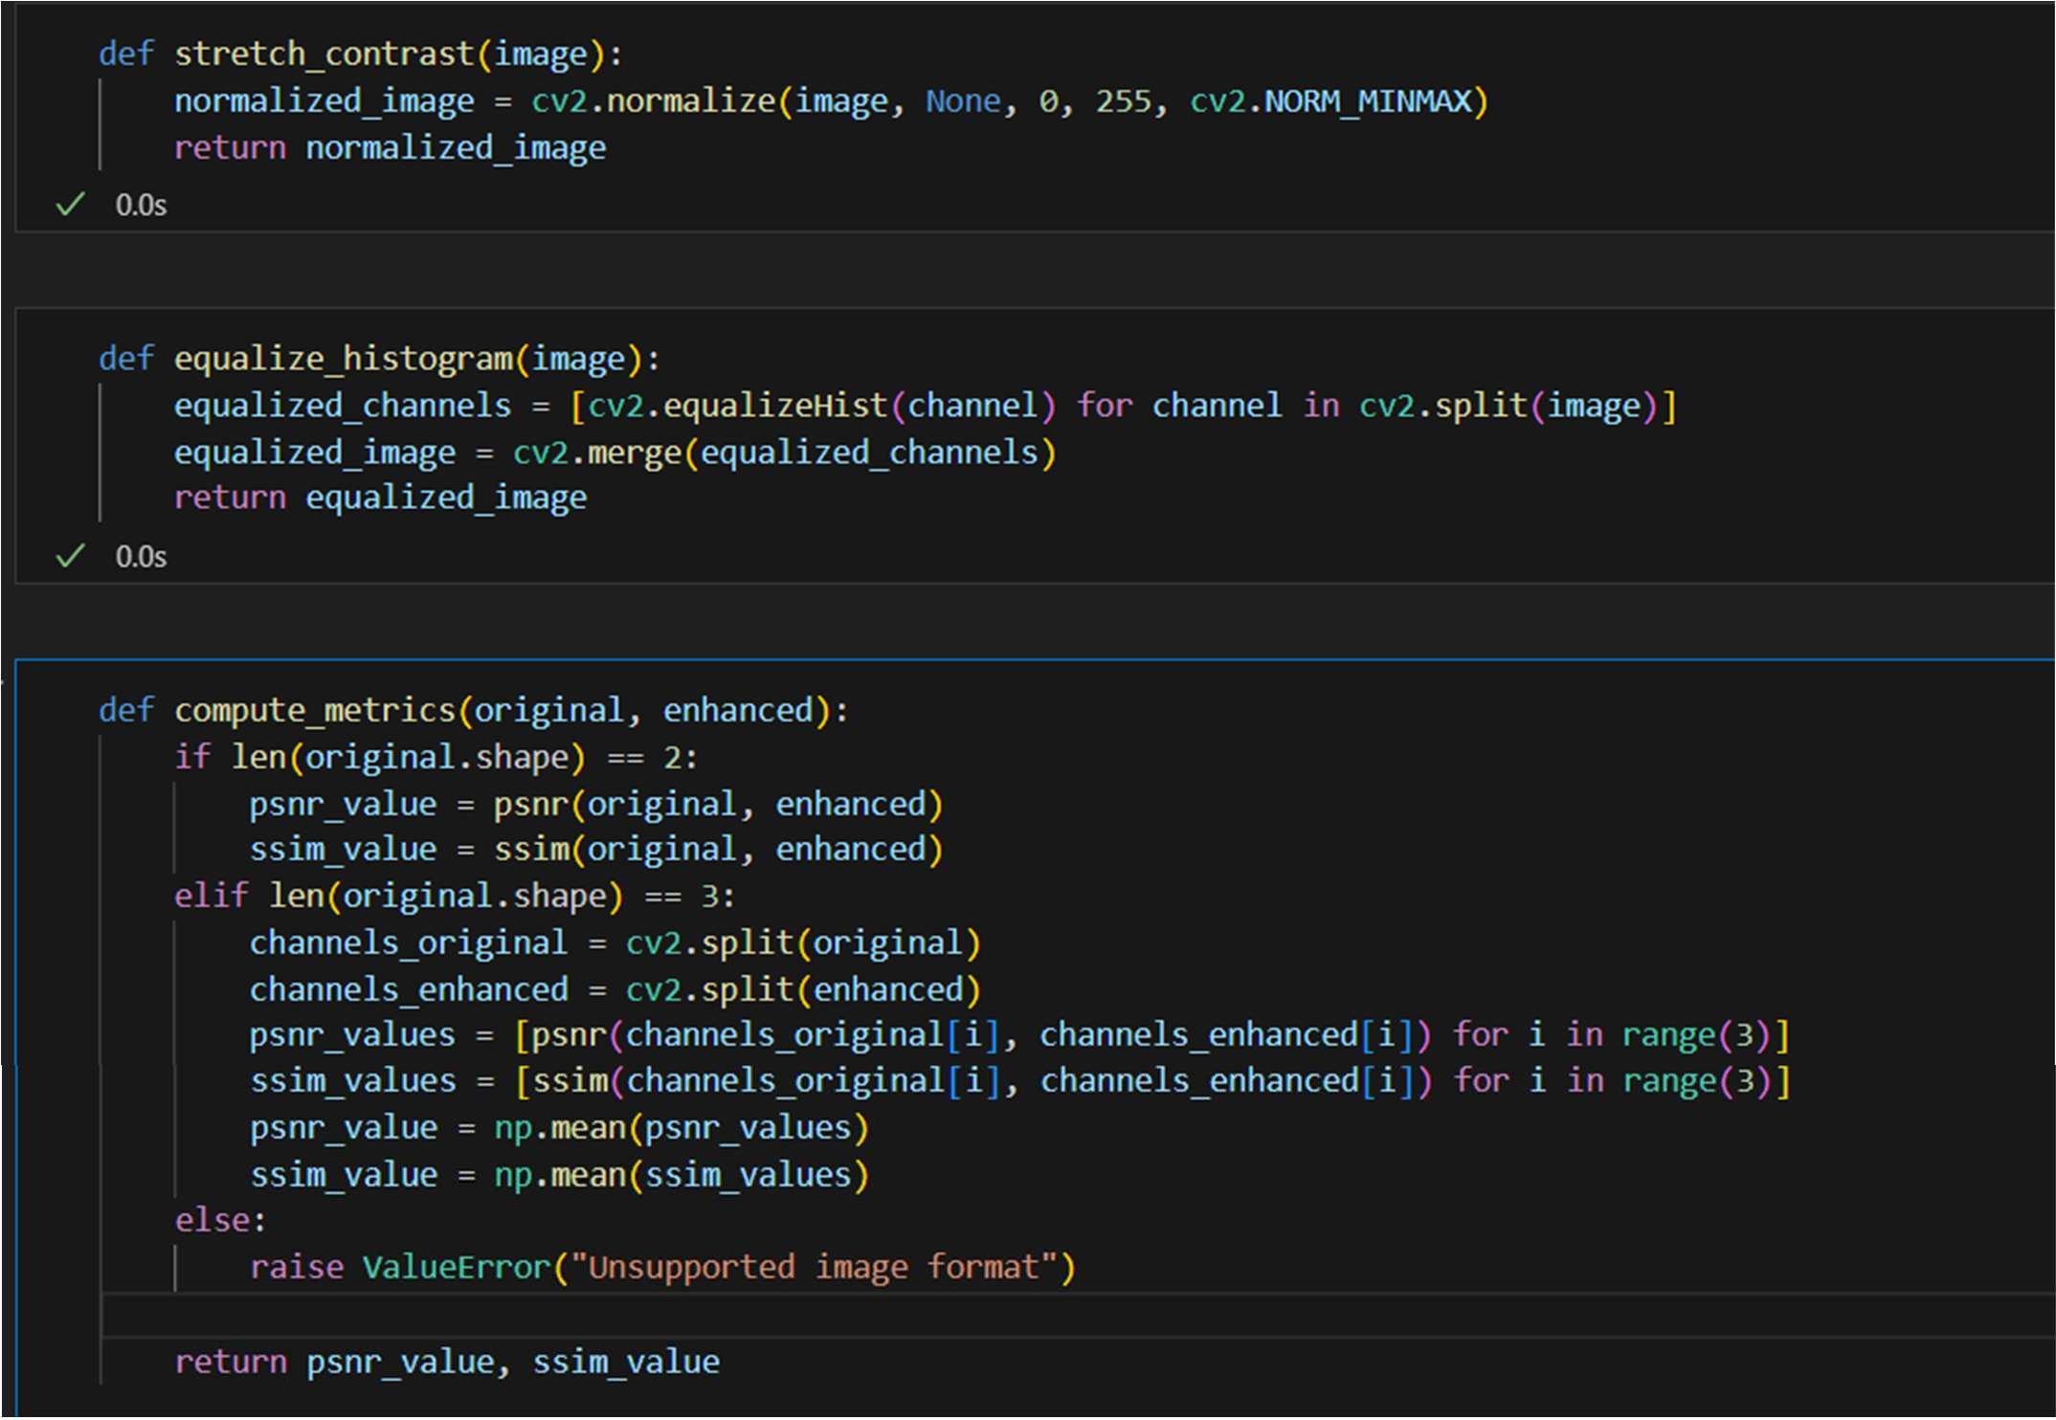

# RESULT:

1. Low-Contrast Image

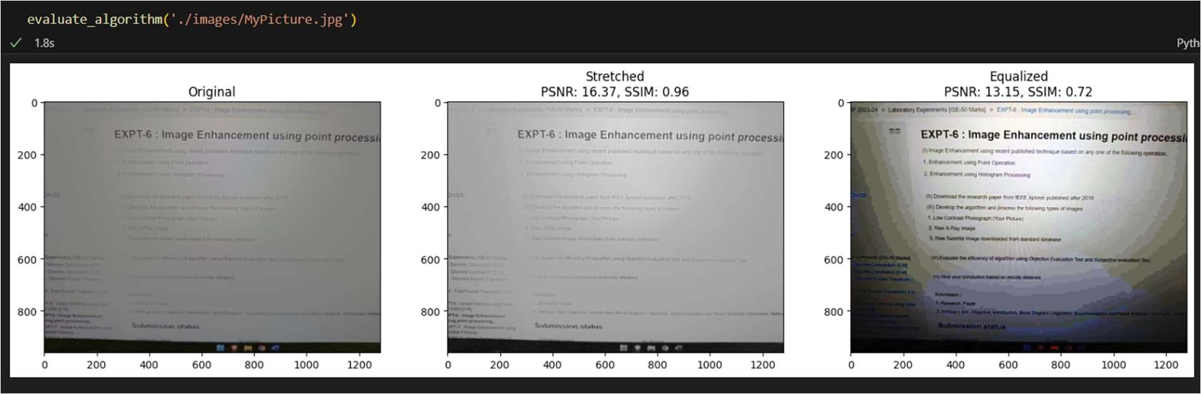

1. Satellite Image

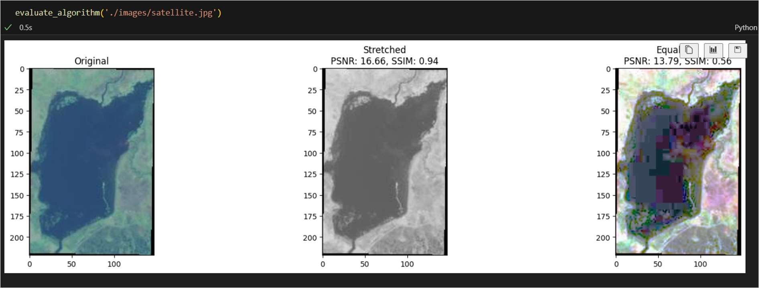

# CONCLUSION:

1. The Histogram Processing gave high enhanced image than stretched processing.
2. The noise was found more in histogram processing.

# REFERENCES:

1. https://geeksforgeeks.org/point-processing-in-image-processing-using-python-opencv/
2. https://[www.geeksforgeeks.org/histogram-equalization-in-digital-image-processing/](http://www.geeksforgeeks.org/histogram-equalization-in-digital-image-processing/)
3. https://cris.fbk.eu/bitstream/11582/315603/5/IEEE_TIP_STAR_2018.pdf